**Idea 1: GPS-Enabled Balloon for Homes**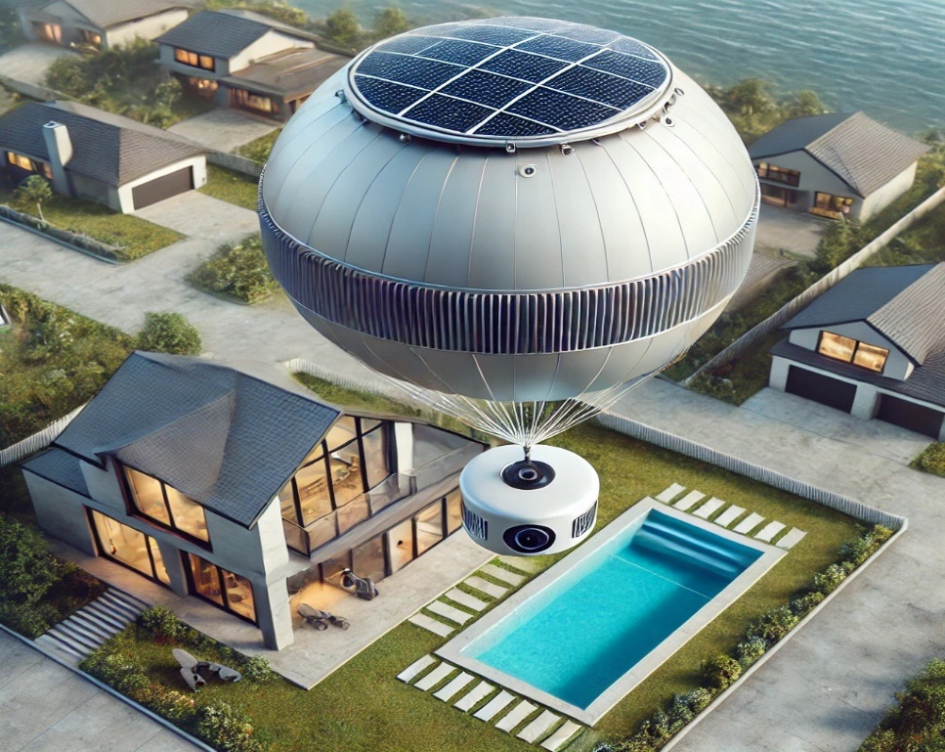

**Figure 1: GPS-enabled balloon system**

**Concept Overview**  
  
The idea is to develop a GPS-enabled balloon system that can float above individual homes at adjustable heights (e.g., 50m, 60m) without being tethered by wires. The system can have various applications, such as providing wireless communication, surveillance, or even aesthetic lighting.

The idea is to have a balloon equipped with cameras, sensors, and communication tools that can monitor the area surrounding a home or property. It would act as a floating “watchman,” either hovering in one location or moving around based on preset patterns or when triggered by motion sensors.  
  
Here are some suggestions, challenges, and a draft hardware plan for this concept:  
  
**Suggestions for the Balloon System**  
  
1. Balloon Material:  
• Use durable, weather-resistant materials like latex, mylar, or high-strength polymers.  
• Incorporate UV protection to ensure longevity and performance in different weather conditions.  
2. Power Source:  
• Solar Panels: Mounted on the balloon for continuous power during the day.  
• Rechargeable Battery: For nighttime or cloudy days, with enough capacity to last through non-solar periods.  
• Energy Harvesting: Optional wind-based energy capture to supplement solar.  
3. GPS & Communication:  
• GPS Module: To allow accurate positioning and altitude control.  
• Wireless Communication: A low-power communication module (e.g., LoRa, ZigBee, or cellular) to enable remote monitoring and control of the balloon from a central hub or smartphone.  
4. Height Adjustment:  
• Helium or Hydrogen Gas: For buoyancy. The balloon would need a controllable valve system to release gas or adjust ballast to achieve various heights.  
• Altitude Sensors: Use barometric pressure or laser rangefinders to maintain and adjust balloon altitude accurately.  
5. Remote Control System:  
• A mobile app or web interface to adjust balloon height, monitor position, and check system diagnostics (e.g., battery, GPS signal, wind speed).  
6. Safety Features:  
• Auto-Descent System: In case of battery failure or extreme weather, the balloon should automatically deflate slowly and descend safely.  
• Geofencing: To prevent the balloon from drifting too far from its intended location, a geofence can trigger automatic descent if it crosses preset boundaries.  
• Collision Avoidance: Sensors to avoid obstacles like trees, power lines, or neighboring buildings.  
  
**Challenges to Address**  
  
1. Weather Resistance:  
• Wind: Strong winds could push the balloon off course. A gyroscopic stabilizer or small propeller system could provide minimal navigation control.  
• Rain and Lightning: Ensure that the electronics are weatherproof and can withstand storms. Balloons could be grounded or retracted in adverse weather conditions.  
2. Gas Leakage:  
• Helium or hydrogen leakage over time will decrease the balloon’s buoyancy. You would need a system for refilling or replacing the gas in intervals.  
3. Air Traffic Regulations:  
• Local regulations for flying objects in controlled airspace would need to be considered. Work with local authorities to ensure compliance with altitude limits and no-fly zones.  
4. Battery Life & Maintenance:  
• Limited battery capacity, especially during non-sunny days, can impact system uptime. Regular maintenance will be required to recharge or replace batteries and ensure consistent operation.  
5. Security & Privacy:  
• The system should be secure to prevent unauthorized access to the GPS module or communication systems. For balloons used for surveillance, privacy concerns from neighbors may arise.  
6. Cost:  
• High-quality components (solar panels, GPS, sensors, communication) could make the initial setup expensive, although it could be mitigated by scalable design.  
  
**Draft Hardware Components**  
  
1. Balloon:  
• Material: High-strength mylar or polyethylene with UV-resistant coating.  
• Size: Based on required lift force, depending on weight of components (likely 2-3 meters in diameter).  
2. Gas & Buoyancy Control:  
• Gas: Helium or hydrogen for buoyancy.  
• Release Valve: To control altitude by adjusting gas volume.  
• Ballast System: Adjustable ballast to change weight dynamically.  
3. Power:  
• Solar Panel: Flexible, lightweight solar panels mounted on the balloon’s surface.  
• Battery: Rechargeable lithium-polymer battery (capacity: 5,000–10,000 mAh) to power electronics during the night.  
4. Sensors:  
• GPS Module: For real-time location tracking.  
• Altitude Sensors: Barometer or laser-based rangefinder to measure and control the height.  
• Weather Sensors: Wind speed and temperature sensors to monitor environmental conditions.  
5. Communication:  
• Wireless Module: Long-range communication (e.g., LoRa or cellular module) to communicate with ground stations or mobile apps.  
• Control System: Microcontroller (e.g., Arduino or ESP32) to manage altitude, GPS data, and communication.  
6. Safety Features:  
• Parachute/Auto-Deflation: In case of malfunction, the balloon should slowly deflate or deploy a small parachute for a controlled descent.  
7. Ground Station:  
• A small control box located at the home, connected via wireless or cellular network, which sends and receives signals to and from the balloon. This could be integrated with a smartphone app.  
  
**Sample Use Cases**  
  
1. Communication Boost:  
• Provides a portable solution to boost WiFi signals or mobile network coverage in areas with poor reception.  
2. Surveillance & Monitoring:  
• Could be equipped with cameras or environmental sensors to monitor surroundings for security or research purposes.  
3. Advertising or Aesthetics:  
• Could be used as floating advertising banners or for decorative lighting, controlled remotely for special events or holidays.  
  
**Key Features for the Home Balloon Surveillance System**  
  
**1. Surveillance System**  
  
• Cameras: Install high-resolution cameras (day/night vision) on the balloon to provide a continuous live feed of the area.  
• Motion Detection: Motion sensors can trigger the camera or alert the system when movement is detected around the house.  
• 360-Degree Coverage: Use a camera with 360-degree rotation to maximize coverage of the area without the balloon needing to move.  
  
**2. Altitude and Movement Control**  
  
• Tethered Balloon: A tethered balloon system can be anchored to a specific location with a flexible wire that supplies power. It will allow the balloon to float at a set height (e.g., 50-60 meters).  
• Untethered (Autonomous): An untethered system could float and change its altitude autonomously, using air ballast or helium control, to adjust for wind and ensure stability.  
• Height Management: Sensors like altimeters or barometers could control the height of the balloon and maintain it within a specific range (e.g., 50-60 meters).  
  
**3. Power System**  
  
• Solar Panels: Lightweight solar panels on the balloon could provide continuous power during the day, with batteries to keep the system running overnight.  
• Battery Backup: Use high-capacity lithium-ion batteries to store excess energy for night-time surveillance.  
  
**4. Communication System**  
  
• Wireless Data Transmission: The surveillance data from the camera could be sent wirelessly to a control station, such as a mobile app or computer system.  
• LoRa or Wi-Fi: A LoRa (Long Range) communication module for large properties or Wi-Fi for closer-range monitoring can transmit the video feed and sensor data in real-time.  
• Alarm System: Integrate with a home security system to trigger alarms or notifications when unusual activities are detected.  
  
**5. GPS and Geofencing**  
  
• Geofencing: Set a virtual perimeter (geofence) for the balloon’s coverage. If the balloon moves outside the designated area (due to strong winds or other factors), an alert can be triggered.  
• GPS Tracking: Use GPS to ensure the balloon stays within the desired location, allowing you to track its position in real-time.  
  
**6. AI-Based Monitoring**  
  
• Object and Motion Detection: An AI-powered camera system can identify different objects (e.g., humans, animals, vehicles) and alert you only when certain activities are detected (e.g., an unauthorized person entering the property).  
• Facial Recognition (Optional): You can integrate facial recognition to distinguish between family members, authorized personnel, and potential intruders.  
  
**Sample Hardware for a Balloon Watchman Prototype**  
  
**1. Balloon**  
  
• Weather Balloon: Use a durable, UV-resistant, helium-filled balloon made of polyethylene to hold the components.  
• Size: A smaller size (~2 meters in diameter) can hold lightweight components and maintain stability in low-altitude conditions.  
  
**2. Surveillance Camera**  
  
• 360-Degree Camera: Use a Pan-Tilt-Zoom (PTZ) camera with night vision (e.g., 1080p resolution).  
• Power Efficiency: Choose a camera with low power consumption to maximize battery life.  
  
**3. Microcontroller**  
  
• ESP32 or Raspberry Pi: Use an ESP32 microcontroller or a Raspberry Pi to manage sensors, camera data, and communication modules.  
  
**4. Sensors**  
  
• Motion Sensors: Passive Infrared (PIR) motion sensors to detect movement around the house.  
• Barometer/Altimeter: Use an altitude sensor (like the BMP280) to control and monitor the balloon’s height.  
  
**5. GPS and Communication**  
  
• GPS Module: Use a GPS module (e.g., Neo-6M) to track the balloon’s position in real-time.  
• LoRa or GSM Module: For long-range communication, you can use a LoRa module or GSM module for sending video and sensor data back to the control station or mobile app.  
  
**6. Power System**  
  
• Solar Panels: Flexible, lightweight solar panels (e.g., 6V, 2W or higher) that charge the onboard battery during daylight hours.  
• Lithium-Ion Battery: Use a high-capacity rechargeable battery (e.g., 3.7V, 6000mAh) for energy storage.  
  
**7. Tethering and Movement Control**  
  
• Tethering Cable: If tethered, use a thin, strong cable to anchor the balloon to the ground while supplying power and data.  
• Motorized Altitude Control: For an untethered version, you can use small air pumps or servos to control the balloon’s altitude autonomously.  
  
**Steps to Build a Prototype**  
  
1. Define Requirements: Determine the specific features you want (e.g., live video feed, motion detection, wireless communication).  
2. Design and Component Selection: Choose the necessary components (balloon, cameras, sensors, microcontroller, GPS, and power system). Select lightweight and power-efficient hardware.  
3. Develop Software: Write software (using Python or C++) for the microcontroller to manage altitude control, GPS tracking, and camera data transmission.  
4. Assemble the Hardware: Connect the camera, sensors, communication module, GPS, and power system to the balloon. If untethered, ensure you have altitude control mechanisms in place.  
5. Testing: Test the balloon’s stability, communication system, and sensor responses in different conditions. Ensure it functions as a watchman by providing real-time alerts and live surveillance.  
6. Refinement: Adjust the design based on testing (e.g., improve stabilization, increase power efficiency).

**Estimated Cost Breakdown**  
  
**1. Balloon and Accessories**  
  
• Weather Balloon (Helium-filled, 2 meters in diameter): $50 - $150  
• Helium Gas (for filling): $30 - $50 (based on usage, could last for multiple deployments)  
• Tethering Cable (optional): $10 - $30  
  
**2. Surveillance Camera**  
  
• 360-Degree PTZ Camera with Night Vision (e.g., 1080p): $100 - $200  
• Mounts and Stabilizers: $20 - $50  
  
**3. Microcontroller or Processing Unit**  
  
• ESP32 (Low-cost): $10 - $20  
• Raspberry Pi (Higher processing capability): $50 - $100  
• Memory (MicroSD Card or Storage): $10 - $20  
  
**4. Sensors**  
  
• Motion Sensor (PIR): $5 - $10  
• Barometer/Altimeter for Height Control: $10 - $30  
• Temperature and Humidity Sensors (optional): $5 - $10  
  
**5. GPS and Communication Module**  
  
• GPS Module: $10 - $30  
• LoRa/GSM Communication Module: $15 - $50  
• Wi-Fi Module (if not included with ESP32): $5 - $10  
  
**6. Power System**  
  
• Flexible Solar Panels (Lightweight, e.g., 6V, 2W): $20 - $50 per panel  
• Lithium-Ion Battery (e.g., 3.7V, 6000mAh): $15 - $40  
• Battery Management System (BMS): $10 - $20  
  
**7. Miscellaneous Components**  
  
• Cables, Connectors, Enclosures for Electronics: $20 - $50  
• Weatherproof Enclosures for Camera and Electronics: $20 - $40  
  
**8. Software Development**  
  
• Basic Microcontroller Programming (DIY): Free if you develop it yourself  
• Advanced Software Features (e.g., AI, facial recognition): Custom development could cost $500 - $2,000+ if outsourced  
  
**Total Estimated Cost for Basic Prototype:**  
  
• Tethered Version: Approximately $300 - $600  
• Untethered (Autonomous) Version: Approximately $500 - $1,000  
  
**Factors Influencing Cost**  
  
• Advanced Features: Adding AI-based recognition or autonomous navigation can increase the cost significantly.  
• Power Management: A more sophisticated solar-powered solution would increase the price but improve sustainability.  
• Scalability: Costs could decrease if components are purchased in bulk or as part of larger production runs.  
  
This rough estimate is based on common off-the-shelf hardware and standard development processes. If you plan to commercialize this system, additional costs for R&D, testing, and regulatory approval would need to be factored in.

**Conclusion**  
  
Building a balloon-based home surveillance system is a unique project that can provide aerial monitoring and act as a “watchman” for your property. Start by developing a simple, tethered system, and once the core functionality works, explore the option of untethered or autonomous systems. Over time, you can enhance the system with AI-based object recognition, smart energy management, and more advanced navigation features. The cost of developing a balloon-based home surveillance system prototype will depend on various factors, such as the components used, the size and complexity of the system, and whether it’s a tethered or autonomous version. Below is an approximate cost breakdown for a basic prototype: